1. **Experiment:** Single-Cell Sorting and Planting
2. **Time:** 2024.12.21-2024.12.28
3. **Member:** Fan Yang, Qiwen Jiang, Xinxin Zhang, Kaiqing Zhang, Meng Sun
4. **Principle:**

Fluorescence-activated cell sorting (FACS) uses target cells’ specific fluorescent signals to isolate individual cells into 96-well plates, ensuring clonal growth from a single cell. Second, in vitro culture mimics physiological conditions to sustain cell viability and proliferation, while inverted microscopy tracks clonal expansion. For sequencing, gentle centrifugation preserves cell integrity during collection; cell lysis releases nucleic acids, enabling high-quality sequencing of clonally pure single-cell samples.

1. **Material:** NK cell media (Gibco, supplemented with 5% FBS and 500 IU/mL IL-2), IL-2 (Gibco), 5% hAB serum (Gibco), Trypan Blue
2. **Method:**
3. Single-Cell Sorting and Planting:
   * 1. FACS was performed under the following conditions: Nozzle size: 100 μm. Sort mode: Single-cell deposition (1 drop/well). Gating strategy: Virus-infected cells were gated based on fluorescence intensity.
     2. Single cells were sorted directly into 96-well plates pre-filled with 150 μL conditioned medium (complete medium + 10% FBS + 1% penicillin-streptomycin).
     3. Negative control wells (medium only, no cells) were included in each plate.
4. Culture and Monitoring:
   * 1. All 20 plates were transferred to cell incubator (37 ℃, 5% CO2) and cultured for 7 days.
     2. Half-medium change was conducted on Day 3:75 μL of spent medium was aspirated and replaced with 75 μL fresh pre-warmed medium.
     3. Clonal growth was monitored daily using an inverted microscope.
5. Cell Collection and sequencing:
   * 1. The 96-well plate is gently tapped to resuspend cells and avoid aggregation.
     2. The suspension from each well is transferred into pre-labelled centrifuge tubes.
     3. The cells were centrifugated at 300 × g for 5 minutes at 4 ℃ and the supernatant is carefully aspirated without disturbing the pellet.
     4. Optionally, the cell pellet is then resuspended in ice-cold PBS, followed by repeated centrifugation to remove residual culture medium.
     5. Finally, the processed cells are directly subjected to lysis and sequencing services were outsourced to Shanghai Biomarker Technologies Co., Ltd.

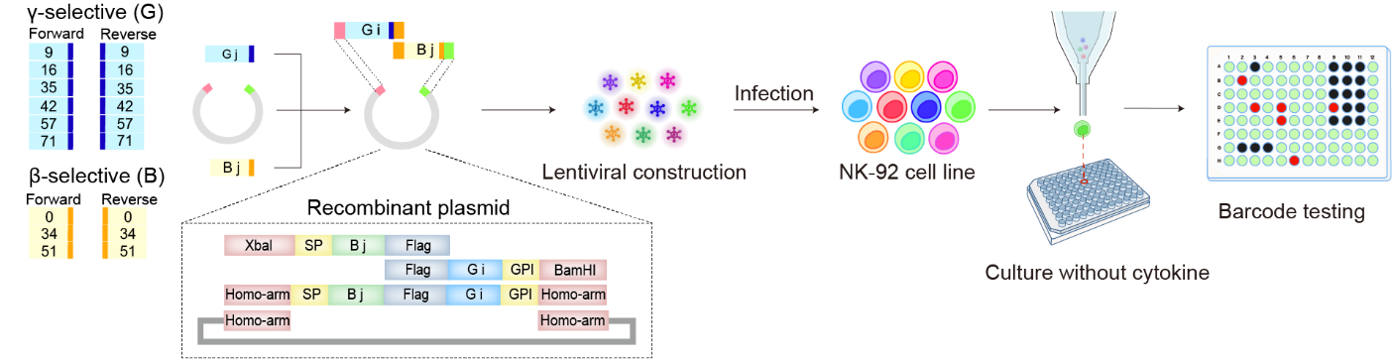

**Fig 1.** Single-Cell Sorting and Planting

Screening for gene combinations that significantly promote NK cell proliferation by infecting NK-92 cells with lentivirus. IL-2β and IL-2γ gene fragments were designed and recombined into various combinations via homologous recombination to construct a plasmid library. The plasmid library was packaged into lentivirus and used to infect NK-92 cells. After culturing for 7 days under cytokine-free conditions, barcode testing was performed to identify significantly proliferating NK cells, and the best-matching gene combination was selected.